Assignment 6: Memory Management

# Name – Akshat Chandrapatle Div- CS-A Roll no.- 45 PRN- 12111449

**Implement following memory management schemes**

**1. Placement Strategies - First fir, Next Fit, Best Fit & Worst fit.**

**2. Buddy System**

**3. Conversion of logical address in to physical address using paging.**

**4. Page replacement algorithms (FIFO, LRU, Optimal)**

1. **Placement Strategies - First fir, Next Fit, Best Fit & Worst fi**

Best fit  
#include <iostream>

using namespace std;

void bestFit(int blockSize[], int m, int processSize[], int n)

{

int allocation[n];

for (int i = 0; i < n; i++)

allocation[i] = -1;

for (int i = 0; i < n; i++)

{

int bestIdx = -1;

for (int j = 0; j < m; j++)

{

if (blockSize[j] >= processSize[i])

{

if (bestIdx == -1)

bestIdx = j;

else if (blockSize[bestIdx] > blockSize[j])

bestIdx = j;

}

}

if (bestIdx != -1)

{

allocation[i] = bestIdx;

blockSize[bestIdx] -= processSize[i];

}

}

cout << "\nProcess No.\tProcess Size\tBlock no.\n";

for (int i = 0; i < n; i++)

{

cout << " " << i + 1 << "\t\t" << processSize[i] << "\t\t";

if (allocation[i] != -1)

cout << allocation[i] + 1;

else

cout << "Not Allocated";

cout << endl;

}

}

int main()

{

int blockSize[] = {100, 500, 200, 300, 600};

int processSize[] = {212, 417, 112, 426};

int m = sizeof(blockSize) / sizeof(blockSize[0]);

int n = sizeof(processSize) / sizeof(processSize[0]);

bestFit(blockSize, m, processSize, n);

return 0;

}

Worst Fit  
  
#include<bits/stdc++.h>

using namespace std;

void worstFit(int blockSize[], int m, int processSize[],int n)

{

int allocation[n];

memset(allocation, -1, sizeof(allocation));

for (int i=0; i<n; i++)

{

int wstIdx = -1;

for (int j=0; j<m; j++)

{

if (blockSize[j] >= processSize[i])

{

if (wstIdx == -1)

wstIdx = j;

else if (blockSize[wstIdx] < blockSize[j])

wstIdx = j;

}

}

if (wstIdx != -1)

{

allocation[i] = wstIdx;

blockSize[wstIdx] -= processSize[i];

}

}

cout << "\nProcess No.\tProcess Size\tBlock no.\n";

for (int i = 0; i < n; i++)

{

cout << " " << i+1 << "\t\t" << processSize[i] << "\t\t";

if (allocation[i] != -1)

cout << allocation[i] + 1;

else

cout << "Not Allocated";

cout << endl;

}

}

int main()

{

int blockSize[] = {100, 500, 200, 300, 600};

int processSize[] = {212, 417, 112, 426};

int m = sizeof(blockSize)/sizeof(blockSize[0]);

int n = sizeof(processSize)/sizeof(processSize[0]);

worstFit(blockSize, m, processSize, n);

return 0 ;

}

First Fit  
#include <bits/stdc++.h>

using namespace std;

void firstFit(int blockSize[], int m, int processSize[], int n)

{

int allocation[n];

memset(allocation, -1, sizeof(allocation));

for (int i = 0; i < n; i++)

{

for (int j = 0; j < m; j++)

{

if (blockSize[j] >= processSize[i])

{

allocation[i] = j;

blockSize[j] -= processSize[i];

break;

}

}

}

cout << "\nProcess No.\tProcess Size\tBlock no.\n";

for (int i = 0; i < n; i++)

{

cout << " " << i + 1 << "\t\t" << processSize[i] << "\t\t";

if (allocation[i] != -1)

cout << allocation[i] + 1;

else

cout << "Not Allocated";

cout << endl;

}

}

int main()

{

// int m;

// cout << "Enter the no. of memory blocks" << endl;

// cin >> m;

// int blockSize[m];

// for (int i = 0; i < m; i++)

// {

// cout << "Enter the size of memory blocks" << endl;

// cin >> blockSize[i];

// }

// int n;

// cout << "Enter the no. of processes" << endl;

// cin >> n;

// int processSize[n];

// for (int i = 0; i < n; i++)

// {

// cout << "Enter the process size" << endl;

// cin >> processSize[i];

// }

int blockSize[] = {100, 500, 200, 300, 600};

int processSize[] = {212, 417, 112, 426};

int m = sizeof(blockSize) / sizeof(blockSize[0]);

int n = sizeof(processSize) / sizeof(processSize[0]);

firstFit(blockSize, m, processSize, n);

return 0;

}

Next fit  
  
#include <bits/stdc++.h>

using namespace std;

void NextFit(int blockSize[], int m, int processSize[], int n)

{

int allocation[n], j = 0, t = m - 1;

memset(allocation, -1, sizeof(allocation));

for (int i = 0; i < n; i++)

{

while (j < m)

{

if (blockSize[j] >= processSize[i])

{

allocation[i] = j;

blockSize[j] -= processSize[i];

t = (j - 1) % m;

break;

}

if (t == j)

{

t = (j - 1) % m;

break;

}

j = (j + 1) % m;

}

}

cout << "\nProcess No.\tProcess Size\tBlock no.\n";

for (int i = 0; i < n; i++)

{

cout << " " << i + 1 << "\t\t" << processSize[i] << "\t\t";

if (allocation[i] != -1)

cout << allocation[i] + 1;

else

cout << "Not Allocated";

cout << endl;

}

}

// Driver program

int main()

{

// int m;

// cout << "Enter the no. of memory blocks" << endl;

// cin >> m;

// int blockSize[m];

// for (int i = 0; i < m; i++)

// {

// cout << "Enter the size of memory blocks" << endl;

// cin >> blockSize[i];

// }

// int n;

// cout << "Enter the no. of processes" << endl;

// cin >> n;

// int processSize[n];

// for (int i = 0; i < n; i++)

// {

// cout << "Enter the process size" << endl;

// cin >> processSize[i];

// }

int blockSize[] = { 5, 10, 20 };

int processSize[] = { 10, 20, 5 };

int m = sizeof(blockSize) / sizeof(blockSize[0]);

int n = sizeof(processSize) / sizeof(processSize[0]);

NextFit(blockSize, m, processSize, n);

return 0;

}

2) **Buddy System**

#include <iostream>

#include <vector>

#include <cmath>

using namespace std;

class Buddy {

public:

class Pair {

public:

int lb, ub;

Pair(int a = 0, int b = 0) : lb(a), ub(b) {}

};

int size;

vector<Pair> arr[100];

Buddy(int s) {

size = s;

int x = (int)ceil(log2(s));

for (int i = 0; i <= x; i++) {

arr[i].clear();

}

arr[x].push_back(Pair(0, size - 1));

}

void allocate(int s) {

int x = (int)ceil(log2(s));

int i;

Pair temp;

if (!arr[x].empty()) {

temp = arr[x][0];

arr[x].erase(arr[x].begin());

cout << "Memory from " << temp.lb << " to " << temp.ub << " allocated" << endl;

return;

}

for (i = x + 1; i < 100; i++) {

if (arr[i].empty()) {

continue;

}

break;

}

if (i == 100) {

cout << "Sorry, failed to allocate memory" << endl;

return;

}

temp = arr[i][0];

i--;

for (; i >= x; i--) {

Pair newPair = Pair(temp.lb, temp.lb + (temp.ub - temp.lb) / 2);

Pair newPair2 = Pair(temp.lb + (temp.ub - temp.lb + 1) / 2, temp.ub);

arr[i].push_back(newPair);

arr[i].push_back(newPair2);

temp = arr[i][0];

arr[i].erase(arr[i].begin());

}

cout << "Memory from " << temp.lb << " to " << temp.ub << " allocated" << endl;

}

};

int main() {

int initialMemory = 0, val = 0;

cout << "Enter size of hard disk KB : ";

cin >> initialMemory;

Buddy obj(initialMemory);

while (true) {

cout << "Enter size of process in KB : ";

cin >> val;

if (val <= 0) {

break;

}

obj.allocate(val);

}

return 0;

}

**OUTPUT:**

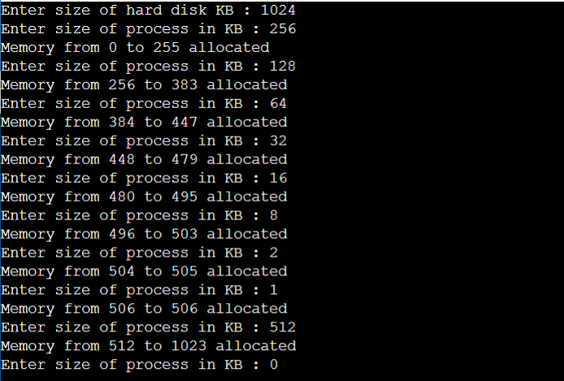

**3. Conversion of logical address in to physical address using paging.**

#include <bits/stdc++.h>

using namespace std;

int ADDRESSMAP(int C_VA, int arr[], int page_size, int n)

{

int pte = C_VA / page_size;

string temp = "";

if (pte >= n)

{

cout << "Page Fault" << endl;

return -1;

}

else

{

return ((arr[pte] * page_size) + (C_VA % page_size));

}

}

int convert(string VA)

{

int n = VA.length();

int a = 1;

int res = 0;

for (int i = n - 1; i >= 0; i--)

{

if (VA[i] == '1')

{

res += a * 1;

}

a = a * 2;

}

return res;

}

int main()

{

int ptr;

int page_size;

string VA;

int C_VA;

int arr[100];

char M[1000][4];

int VA_SPACE = 100;

int READ_SPACE = 300;

cout << "Enter the size of the page: ";

cin >> page_size;

cout << endl;

int n;

cout << "Enter the number of entries in the page table:" << endl;

cin >> n;

cout << "Enter the contents of the page table";

for (int i = 0; i < n; i++)

{

cin >> arr[i];

}

cout << "Enter binary virtual address: ";

cin >> VA;

C_VA = convert(VA);

cout << "The real address is:" << ADDRESSMAP(C_VA, arr, page_size, n) << endl;

}

**OUTPUT:**

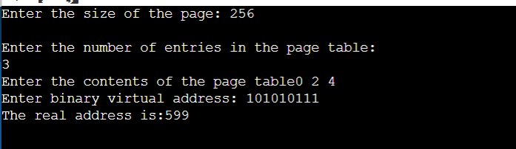

**4. Page replacement algorithms (FIFO, LRU, Optimal)**

**FIFO**

#include <iostream>

#include <queue>

using namespace std;

int main() {

int n_frames, n_pages, page_faults = 0;

cout << "Enter the number of frames: ";

cin >> n_frames;

cout << "Enter the number of pages: ";

cin >> n_pages;

int pages[n_pages];

cout << "Enter the page references: ";

for (int i = 0; i < n_pages; i++) {

cin >> pages[i];

}

queue<int> frame;

bool is_page_present[n_pages] = { false };

cout << "Reference String\tFrames\t\tPage Fault\n";

cout << "-------------------------------------------------------\n";

for (int i = 0; i < n_pages; i++) {

cout << pages[i] << "\t\t\t";

if (!is_page_present[pages[i]]) {

if (frame.size() == n_frames) {

int removed_page = frame.front();

frame.pop();

is_page_present[removed_page] = false;

}

frame.push(pages[i]);

is_page_present[pages[i]] = true;

for (int j = 0; j < frame.size(); j++) {

int temp = frame.front();

frame.pop();

cout << temp << " ";

frame.push(temp);

}

page_faults++;

cout << "\t\tMiss";

} else {

for (int j = 0; j < frame.size(); j++) {

int temp = frame.front();

frame.pop();

cout << temp << " ";

frame.push(temp);

}

cout << "\t\tHit";

}

cout << endl;

}

cout << "\nNumber of page faults: " << page_faults << endl;

return 0;

}

**OUTPUT:**

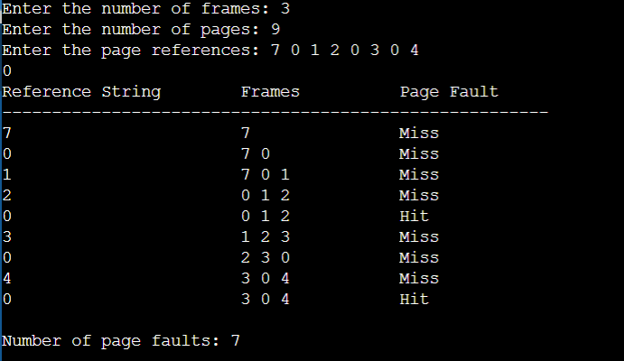

**LRU**

#include <iostream>

#include <algorithm>

#include <deque>

using namespace std;

int main() {

int num_frames, num_pages, page_faults = 0;

cout << "Enter the number of frames: ";

cin >> num_frames;

cout << "Enter the number of pages: ";

cin >> num_pages;

int pages[num_pages];

cout << "Enter the page references: ";

for (int i = 0; i < num_pages; i++) {

cin >> pages[i];

}

deque<int> frame_deque;

bool is_page_present[num_pages] = { false };

cout << "Reference String\tFrames\t\tPage Fault\n";

for (int i = 0; i < num_pages; i++) {

cout << pages[i] << "\t\t\t";

if (!is_page_present[pages[i]]) {

if (frame_deque.size() == num_frames) {

int removed_page = frame_deque.back();

frame_deque.pop_back();

is_page_present[removed_page] = false;

}

frame_deque.push_front(pages[i]);

is_page_present[pages[i]] = true;

page_faults++;

for (int j = 0; j < num_frames; j++) {

if (j < frame_deque.size()) {

cout << frame_deque[j] << " ";

} else {

cout << " ";

}

}

cout << "\t\t";

cout << "Fault";

cout << endl;

} else {

frame_deque.erase(find(frame_deque.begin(), frame_deque.end(), pages[i]));

frame_deque.push_front(pages[i]);

for (int j = 0; j < num_frames; j++) {

if (j < frame_deque.size()) {

cout << frame_deque[j] << " ";

} else {

cout << " ";

}

}

cout << "\t\t";

cout << "Hit";

cout << endl;

}

// for (int j = 0; j < num_frames; j++) {

// if (j < frame_deque.size()) {

// cout << frame_deque[j] << " ";

// } else {

// cout << " ";

// }

// }

// cout << "\t\t";

// if (!is_page_present[pages[i]]) {

// cout << "Fault";

// } else {

// cout << "Hit";

// }

// cout << endl;

}

cout << "\nNumber of page faults: " << page_faults << endl;

return 0;

}

**OUTPUT:**

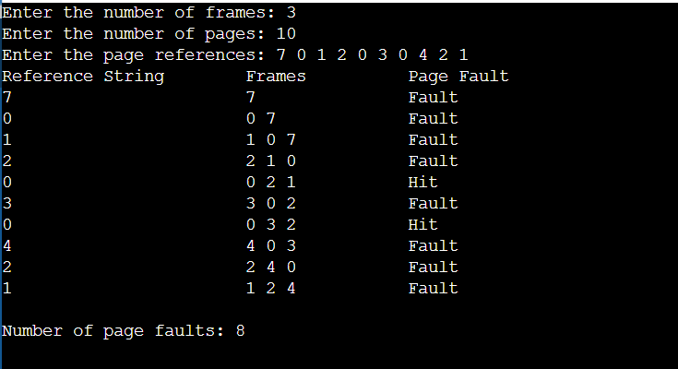

**OPTIMAL:**

#include <iostream>

#include <algorithm>

using namespace std;

int main() {

int num_frames, num_pages, page_faults = 0;

cout << "Enter the number of frames: ";

cin >> num_frames;

cout << "Enter the number of pages: ";

cin >> num_pages;

int pages[num_pages];

cout << "Enter the page references: ";

for (int i = 0; i < num_pages; i++) {

cin >> pages[i];

}

int frames[num_frames];

bool is_page_present[num_pages] = { false };

int next_use[num_frames];

cout << "Reference String\tFrames\t\tPage Fault\n";

for (int i = 0; i < num_pages; i++) {

cout << pages[i] << "\t\t\t";

if (!is_page_present[pages[i]]) {

if (page_faults < num_frames) {

frames[page_faults] = pages[i];

next_use[page_faults] = find(pages + i + 1, pages + num_pages, pages[i]) - pages;

} else {

int index = 0;

for (int j = 1; j < num_frames; j++) {

if (next_use[j] > next_use[index]) {

index = j;

}

}

//cout<<index<<endl;

is_page_present[frames[index]] = false;

frames[index] = pages[i];

next_use[index] = find(pages + i + 1, pages + num_pages, pages[i]) - pages;

}

page_faults++;

is_page_present[pages[i]] = true;

for (int j = 0; j < num_frames; j++) {

if (j < page_faults) {

cout << frames[j] << " ";

} else {

cout << " ";

}

}

cout << "\t\tMiss";

} else {

for (int j = 0; j < num_frames; j++) {

if (j < page_faults) {

cout << frames[j] << " ";

} else {

cout << " ";

}

}

cout << "\t\tHit";

}

cout << endl;

}

cout << "Page faults: " << page_faults << endl;

return 0;

}

